INSTRUCTIONS FOR REGISTRATION WITH Web of Science
Updated: 20.06.2023.

If you are an author, a present or future member of the Editorial Board or a reviewer of the Military Technical Courier, you are kindly asked to register in the WoS database.

IMPORTANT: Prior to registering in WoS, it is advisable to register in the ORCID database, following the instructions given at http://www.vtg.mod.gov.rs/registration-for-an-orcid-identifier.html, because there is a possibility to import the data from ORCID into WoS (since these two major international bases have been integrated) in the following way: in your WoS profile open MENU - Profile - Publications - Add publications - Sync with ORCiD – log into your ORCID – Authorize Clarivate.

After creating a profile in WoS, you can import all your articles and reviews for the Military Technical Courrier (and other scientific journals as well) to your profile page, regardless of the time they have been published/done. This is in your best interest as a scientific researcher as well as in the interest of our journal.

Registration and data entry

1. Open the page
https://access.clarivate.com/login?app=wos
2. After that, you will receive an offer to register:

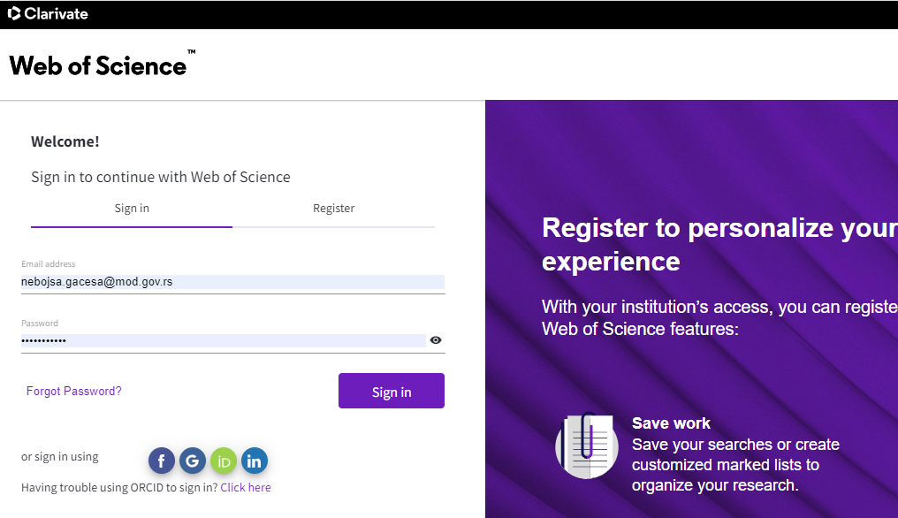

You can register directly or via your accounts in ORCID or LinkedIn.
3. You then need to provide all the required data by clicking on the MENU - Profile - My researcher profile - EDIT field in the left column. You are kindly reminded not to forget to submit a photo.
The members of the Editorial Board of the Military Technical Courier should enter VojnotehnickiGlasnik/Military Technical Courier in the field MENU - Profile - Editorial Board Memberships - Add an editorial board membership (the system automatically recognizes the journal’s title after entering its initial letters):
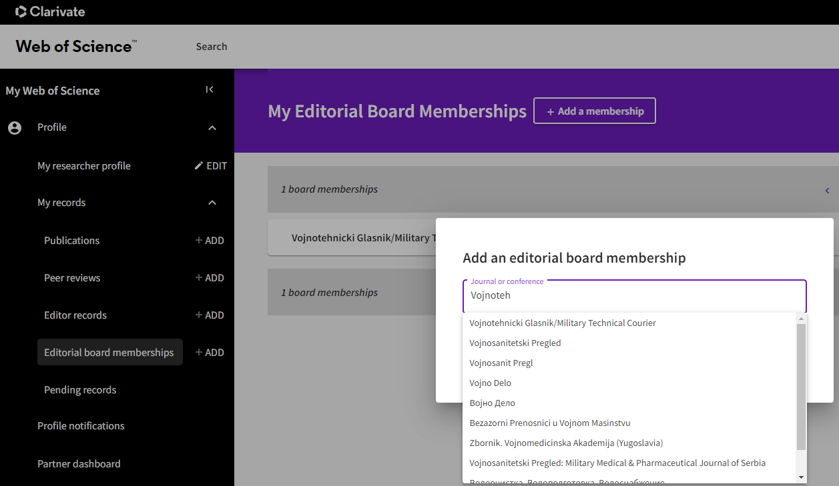
4. The purpose of your WoS account is to showcase your papers and reviews.
a) To enter an article, use the field MENU - Profile - My records - Publications - Add publication (in the left column).
After that, you will be able to import all the papers through the options:
- Suggested publications, Add publications by identifier (by entering the doi number of the article), Add publications by file upload or
- Sync with ORCiD: This step alows you to import all your papers via your ORCID identifier (use the offered ORCID link and then click the option Authorized Clarivate – after a while, all your papers from ORCID will be visible in WoS). This is why your ORCID identifier should ALWAYS be updated (in accordance with GUIDELINES FOR THE REGISTRATION AND UPDATING OF THE ORCID IDENTIFIER at http://www.vtg.mod.gov.rs/registration-for-an-orcid-identifier.html ).

b) To enter a review, use the field MENU - Profile - My records - Per reviews - Add a review (in the left column). It is necessary to enter the reviewed article’s title and the review’s date but the visibility of the Review Content is optional – you can choose whether to enter the whole text of your review.
Note: You can import all your previously done reviews for the Military Technical Courier retroactively as well as future ones.
The simplest way is to search your inbox for “Thank you for reviewing” emails the journal editors have sent to you and forward such emails to reviews@webofscience.com. Not only can pre-publication reviews be added but also post-publication, i.e. already published ones. Every added review is subsequently verified by the journal editor – you can follow this through the MENU - Profile - Profile Notifications field (in the left column).

WoS profiles make your reviews visible to other journals and conferences thus showing your availability for cooperation. Besides, all relevant bibliographic data of reviewers/authors is given in one place, e.g. participation in editorial boards of journals, participation in program committees of international conferences, published scientific papers and reviews in international journals and conference proceedings. To registered reviewers, WoS platform also offers activity statistics tracking and other useful information.
You can read more details on the WoS page:
https://clarivate.com/products/scientific-and-academic-research/research-discovery-and-workflow-solutions/researcher-profiles/

Editor of Vojnotehnicki Glasnik/Military Technical Courier
Nebojša Gaćeša

